2022
Annual Plan

ScottishPower Foundation

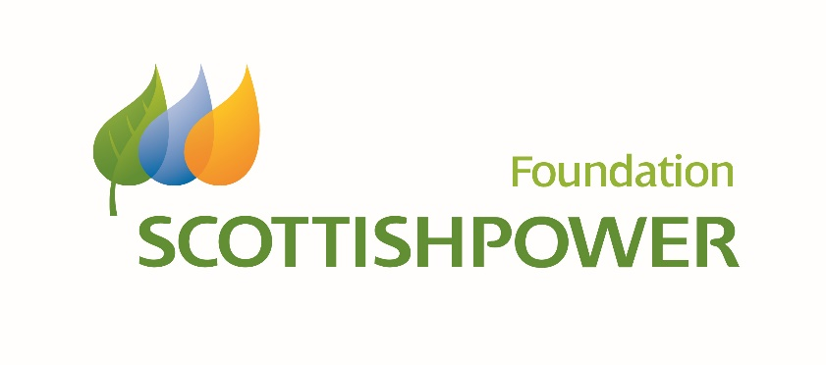
- Introduction

The ScottishPower Foundation was established in 2013 by ScottishPower, which is part of the Iberdrola Group; one of the world’s largest integrated utility companies and a world leader in wind energy.

Within its Master Plan 2022-2025, the Iberdrola Foundations Committee sets the general strategy, planning, evaluation and reporting for all five Foundations within the Iberdrola Group. It serves as a guide for all of the Foundations to prioritise and align actions of common interest, whilst recognising that there may be individual requirements within each country.

The ScottishPower Foundation has created a complementary Strategic Plan which aligns closely with the Master Plan whilst adapting it for the UK.

Within this framework, the ScottishPower Foundation publishes an Annual Plan each year, setting out its budget, annual funding programme and indicators for evaluating success. This is the Annual Plan 2022.

External Impact on the Foundation’s Annual Plan 2022

In recognition of ongoing challenges presented by COVID-19, and the operational uncertainties this creates, the ScottishPower Foundation is keen to be as supportive and flexible as reasonable in relation to its 2022 grants. The Board has agreed to the following three possible scenarios:

1. Project delivered in line with agreed milestones and deliverables
2. Project has to be adapted in terms of what is delivered and/or when

In exceptional circumstances, where the above scenarios result in the project being scaled back;

3. Remaining funding may be redirected to core costs

Whilst the Board strongly prefers scenarios 1 and 2, it recognises that there may be exceptional circumstances in which part of the grant must be redirected to core costs. In such cases, careful checks will be carried out to ensure that the organisations’ wider charitable objects are consistent with those of the ScottishPower Foundation as outlined in its Articles of Association.

- Commitment to the Sustainable Development Goals (SDGs)

The Sustainable Development Goals (SDGs), are an urgent call for action by all countries - developed and developing - in a global partnership. They recognise that ending poverty and other deprivations must go hand-in-hand with strategies that improve health and education, reduce inequality, and spur economic growth – all while tackling climate change and working to preserve our oceans and forests.

The ScottishPower Foundation is committed to helping achieve these goals, with a particular focus on Goal 3 – Good Health and Well-Being, Goal 4 – Quality Education, Goal 13 – Climate Change, and Goal 10 – Reduced Inequalities.

- General Objectives
The ScottishPower Foundation’s Strategic Plan sets out the overall purpose of its support for charitable work as:
- Education, Training and Research - To support education, training and research in general, prioritising innovation in order to contribute to energy sustainability.
- Biodiversity and Climate Change - To support the protection of the environment and to enhance biodiversity, to actively contribute in the fight against climate change.
- Art and Culture - To protect and safeguard artistic and cultural heritage by promoting conservation and restoration of the arts and supporting local development.
- Social Initiatives - To contribute to sustainable human development by supporting the most vulnerable people and groups.

- Specific Objectives

The below tables outline the specific objectives that are linked to the grants approved for 2022, including the target groups and associated SDGs and targets.

EDUCATION, TRAINING AND RESEARCH
SPECIFIC OBJECTIVES | GROUP | SDGs | TARGETS
STEM - To inspire young people to pursue qualifications and a career in STEM in order to contribute to energy sustainability. | Registered charities |   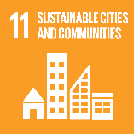  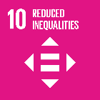  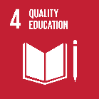  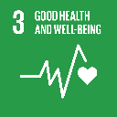 | 3.4  4.5  4.7  10.2  11.4  13.3
Raising Aspirations - To inspire and challenge the next generation to support the search for better and more innovative ways to meet society’s educational needs. | Registered charities |  | 3.4  4.5  4.7  10.2  11.4  13.3

BIODIVERSITY AND CLIMATE CHANGE
SPECIFIC OBJECTIVES | GROUP | SDGs | TARGETS
Environmental Protection or Improvement - To protect and enhance the environment. | Registered charities | 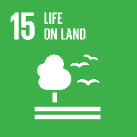 | 3.4  4.7  11.4  13.3  15.1  15.2
Habitat Conservation - To contribute to the protection and conservation of habitats and enhance biodiversity. | Registered charities |  | 3.4  4.7  11.4  13.3  15.1  15.2
Knowledge & Research - To develop new solutions to the challenge of climate change. |  |  | 3.4  4.7  11.4  13.3  15.1  15.2

ART AND CULTURE
SPECIFIC OBJECTIVES | GROUP | SDGs | TARGETS
Restoration, Development & Conservation - To protect and safeguard artistic and cultural heritage. | Registered charities | 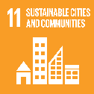  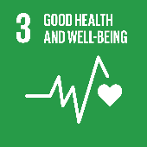  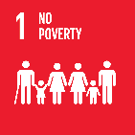 | 1.4  3.4  4.4  4.5  4.7  10.2  11.4  13.3
Cultural Initiatives - To celebrate diversity and cultural identity through the arts. | Registered charities |  | 1.4  3.4  4.4  4.5  4.7  10.2  11.4  13.3

SOCIAL INITIATIVES
SPECIFIC OBJECTIVES | GROUP | SDGs | TARGETS
Poverty, Disability & Disadvantage - To contribute to tackling disadvantage in society, promoting equal opportunities. | Registered charities |  | 1.4  3.4  4.4  4.5  10.2
Citizenship & Community Development - To contribute to the enrichment of peoples’ lives in communities by celebrating diverse culture and strengthening citizenship. |  |  | 1.4  3.4  4.4  4.5  10.2

- 2022 Annual Projects
The Foundation has agreed to support the following annual projects during 2022:

EDUCATION, TRAINING AND RESEARCH

The Movement for Non-mobile Children
Wheeling for Independence
By project’s end, 300 disabled children will have the skills they need to use their wheelchairs more independently. This unlocks countless opportunities to learn, make friends and be active which, since March 2020, so many have been without. The charity will run new sessions in Scotland and Wales, and train 40 new practitioners, so no young wheelchair user is left behind.

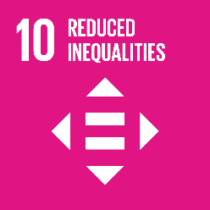
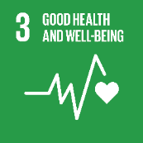
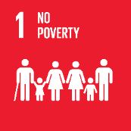
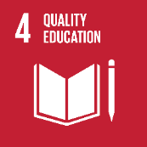

Engineering Development Trust

Industrial Cadets Bronze and Our Green Garden Project

EDT and Industrial Cadets want more young people to: - Understand STEM better, engaging with STEM employers - Develop life/employability skills - Personally, experience using STEM to solve an environmental challenge. Local gardens have a positive role to play to address environmental issues. EDT will use a gardening based environmental challenge to inspire young people towards STEM and environmental futures.


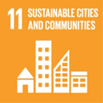

Deafblind UK

Fitting In and Standing Out

A research project, to be conducted in schools, to enable Deafblind UK to understand the needs and support required for children and young people with dual sensory loss. It will inform the need for services to address acute discrepancies. Consequently, the research will enable children and young people to participate fully in school, providing equal opportunities to their peers, allowing them to excel academically and socially. Long term, this will help increase independence and enhance lives.

Edinburgh Science Foundation Ltd
Generation Science 2022
This project will help to improve primary science education for children in the most deprived areas of Scotland, providing opportunities they would not normally get to experience fun, engaging science workshops and shows that increase understanding, enthusiasm and awareness of science as it affects their everyday lives. This contributes to raising aspirations and supports the Scottish economy.

BIODIVERSITY AND CLIMATE CHANGE
The Froglife Trust
Fife Living Water
The restoration of Cowdenbeath Wetland and the creation of freshwater at Swan Pond, Cowdenbeath. Cowdenbeath Wetland which is situated in Cowdenbeath is, due to late succession, no longer functioning as a wetland, with the freshwater bodies heavily vegetated preventing them from holding water.
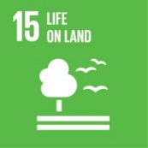
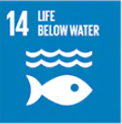
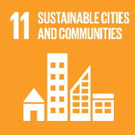
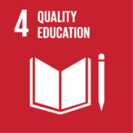

Cheshire Wildlife Trust

Wasted space, an Urban Transformation

Wasted Space, an Urban Transformation will support volunteers and community groups to deliver activities to boost biodiversity and transform otherwise wasted community spaces into wildlife havens on their doorstep. It will improve the wellbeing of a wide range of local people and the project will equip them with the skills and knowledge to protect the nature in their neighbourhood going forward.

Keep Britain Tidy

Ocean Recovery project

The project will expand on successful pilot project in SW England to prevent the dumping redundant fishing nets at sea. These ‘ghost nets’ are greatly damaging to marine ecosystems and habitats. The project will develop a viable long-term solution through a UK-based recycling system. This will promote the health and resilience of our marine eco-systems, habitats and native species.

Buglife The Invertebrate Conservation Trust

Pollinators along the Tweed

The project will help protect threatened pollinator insects such as bees and butterflies within the River Tweed catchment, crossing the England-Scotland border. By restoring wildflower meadows and grasslands, Buglife will protect biodiversity and enable insect populations to recover and flourish. The project will support communities, schools and businesses to improve local greenspaces for wildlife, and contribute to peoples’ health and wellbeing.

Ocean Conservation Trust

Seagrass Restoration Co-operative

Seagrasses are one of the most valuable habitats on the planet. They absorb carbon, are a nursery for fish and reduce coastal erosion. UK seagrasses are declining. This project seeks to pilot an innovative and holistic process to enable large-scale restoration. The legacy will be a blueprint for increased carbon sequestration and biodiversity plus support for fisheries and coastal communities.

ART AND CULTURE
Cutting Edge Theatre

Inspire Disability Arts

Cutting Edge Theatre are working to establish equal access to the performing arts for those who have learning disabilities in Scotland, by introducing a national strategy to establish a "ladder" structure from Primary School age all the way through to professional training and employment.

Coldharbour Mill Trust

Heritage Craft Skills Programme

This project responds to local community needs for skills training opportunities and employment, and the curricular needs of educational institutions, while contributing to this charity’s responsibility to protect, preserve and pass on heritage craft skills.
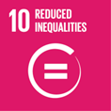

National Library of Scotland

Scotland’s Tapes Go Digital

An important collection of video and audio tapes will soon be lost forever, unless NLS acts quickly to digitise its content. A rich treasure trove of cultural heritage from the 1950s to the 2000s, this material will fascinate, amuse, educate and inspire people, as the National Library of Scotland celebrates the Centenary of Broadcasting in Scotland in 2023.

SOCIAL INITIATIVES
Linkage Community Trust

Linkage Sensory Outreach Project

The Sensory Bus will visit 12 schools throughout Greater Lincolnshire to provide a sensory resource where it is most needed. Rural isolation makes it difficult for many families to access support for their children with Special Educational Needs (SEN), and sensory therapy is known to have many developmental and therapeutic benefits as well as improving feelings of well-being and happiness.

The Lorna Young Foundation

Freeing Up Ethical Enterprise Training- NEETs and Not Just Us

Creating *free-to-all* access to our Ethical Entrepreneurs ('Not Just Us') training resources, which will be piloted with NEETs in Greater Manchester, within a community enterprise context. This will improve economic and employment chances of NEETs and foster local ethical and environmental responsibility. At the project end, the resources can then be used for free - by any marginalised UK group.

Green Team (Edinburgh and Lothians)

Green Shoots

Project will enable delivery of the full Green Shoots 2022/23 programme. Each project lasts between 7-10 weeks (with an advanced project that includes 2 residential weekends). Groups of 8 young people will take part in a full day session, once a week over the course of a project. Additionally, 1-1 reviews are held at outset and participants take part in an end of project celebration.

Street League

Levelling the playing field: providing a digital lifeline for young people across Scotland

Responding to the devastating impact of COVID-19, Levelling the Playing Field will work with vulnerable young people across Scotland who have left school with few or no qualifications. Through the award-winning sport and employability programme, the project will provide 1,000 young people with the second chance they deserve to gain qualifications and move into sustained employment, education, or further training.

Headway Swindon & District

One Step at a Time out of Mental Health

The charity’s clients struggle with mental health and well-being following their brain injury. The project will improve this struggle for them one step at a time. Showing survivors there is a way to recover through bespoke brain injury therapy to improve outcomes, reduce isolation and suicidal ideations, and increase education and understanding within communities.

Linkes (SCIO)

Linkes Community Food Project

Linkes innovative Community Food Project will empower people on the Lincoln estate to have a voice and develop local solutions to poverty and food resilience. The project will build on a Food Hub pilot, to create a dedicated Community Food Hub on the high-rise estate providing access to healthy food and progressing growing opportunities, community events, increased biodiversity and meaningful volunteer roles.

Playlist for Life

Music Connects Communities

The charity’s Help Point programme will support families living with dementia by expanding and supporting a UK-wide network of Help Points to reach people with dementia in their own communities and use music to improve their health, well-being, and social connections.

- Budget per Theme
Category | Amount
Education, Training & Research | £123,399.00
Biodiversity & Climate Change | £353,691.00
Art & Culture | £212,000.00
Social Initiatives | £450,910.00

- Impact Indicators 2022
IMPACT INDICATORS 2022
EDUCATION, TRAINING AND RESEARCH
Charity | Project | Direct Impact Indicator | Impact  on SDG Goals/Targets | Other achievements
The Movement for Non-Mobile Children | Wheeling for Independence | Establish 15 new schools partnerships or community sessions and deliver on 35 existing schools’ partnerships. | 3.4  4.5  10.2 | Deliver 15 Wheelchair Skills for Sports sessions and 300 hours of Wheelchair Skills Training overall
Engineering Development Trust | Industrial Cadets Bronze and Our Green Garden Project | 100 young people completing projects and gaining an Industrial Cadets bronze award. | 3.4  4.5  4.7  11.4  13.3 | Young people developing life and employability skills, as identified in feedback from students, mentors and assessors.
Deafblind UK | Fitting in and Standing Out | Training will be delivered in 21 schools with a minimum of 40 beneficiaries (deafblind students). | 3.4  4.5  4.7  11.4  13.3 | Develop a suite of materials to enable teachers and local authority sensory service providers to conduct structured training.
Edinburgh Science Foundation Limited | Generation Science 2022 | Provide 6-8 high quality STEM activities for schools which support teachers to deliver the Curriculum for Excellence. | 4.5  4.7  10.2 | Recruit and train two Science Communicators  per activity
BIODIVERSITY AND CLIMATE CHANGE
The Froglife Trust | Fife Living Water | Deepen existing scrapes and reprofile Swan Pond and improve terrestrial habitat and wooded areas | 3.4  13.3  15.1  15.2 | One school volunteering session will be delivered a month to a total of 160 pupils over the course of the project
Cheshire Wildlife Trust | Wasted Space, an Urban Transformation | 200 wasted spaces will be identified and mapped and at least 10 sites will be adopted and transformed by communities | 3.4  13.3  15.1  15.2 | 1,200 people engaged by community champions in the transformation of wasted spaces.
Keep Britain Tidy | Ocean Recovery Project | Establish net recycling systems for at least four fishing ports, ensuring that at least 50 additional tonnes per annum are not disposed of at sea, but are reprocessed and contribute to the circular economy | 11.4  13.3 | Support up to 10 additional beach-cleaning volunteer groups to collect and segregate nets and other marine plastic for reprocessing
Buglife The Invertebrate Conservation Trust | Pollinators along the Tweed | 10 Hectares of land enhanced for pollinators and 5 community events, talks and volunteer work parties | 3.4  4.7  11.4  13.3  15.1  15.2 | 10 communities engaged with the project, increasing awareness of pollinator needs along the River Tweed
Ocean Conservation Trust | Seagrass Restoration  Co-operative | Selection of the preferred restoration site and the completion of the base line carbon and biodiversity surveys. | 3.4  4.7  13.3 | The installation of 5 Advanced Mooring Systems and the protection buoys defining the restoration area
ART AND CULTURE
Cutting Edge Theatre | Inspiring Disability Arts | 20 young people aged 14-18 who have learning disabilities will be able to attend a weekly youth theatre in Edinburgh. | 3.4  4.4  4.5  10.2 | 20 young people aged 18-25 who have learning disabilities will be able to attend a weekly Young Company, training in the performing arts.
Coldharbour Mill Trust | Heritage Craft Skills Programme | Online virtual experiences reaching at least 2000 people and new skills New skills developed by 75% of participants | 3.4  4.4  4.5  10.2  11.4 | 6 Further/Higher Education student work experience placements and  8 on-site textile spinning and weaving workshops for approximately 100 participants
National Library of Scotland | Scotland’s Tapes Go Digital | 5,000 tapes are digitised, catalogued, and made available to the public in Glasgow and Edinburgh. | 3.4  11.4 | An event celebrating the first ever public radio broadcast transmission received in Scotland is held at Kelvin Hall, using the material, as part of the Centenary of Broadcasting, attracting visitors to Glasgow.
SOCIAL INITIATIVES
Linkage Community Trust | Linkage Sensory Outreach Project | 7 days of sensory bus work in each of 12 school partners will be delivered (84 sessions in all) spread evenly across the 3 school terms of 2022 | 3.4  10.2 | 85% of children report being better able to be calm
The Lorna Young Foundation | Freeing Up Ethical Enterprise Training- NEETs and Not Just Us | 4 new NEET led ethical enterprises to be established selling either ethical products or services with 40 NEETs progressing through the 12-month training to become an ethical entrepreneur. | 1.4  3.4  4.4  4.5  10.2 | 16 community events/early selling experiences to be held where the new products are market tested and community support is gathered.
Green Team Edinburgh and Lothians | Green Shoots | Provide projects for 56 young people with attendance rate over 75% and deliver 7 projects (64 full-day sessions) | 3.4  4.4  4.5  10.2 | Participants experience improved emotional and mental wellbeing, and improved confidence and self-esteem
Street League | Levelling the playing field: providing a digital lifeline for young people across Scotland | 1,000 young people will start the project across six regions in Scotland, developing confidence and essential skills for work. | 1.4  3.4  4.4  4.5  10.2 | 800 qualifications will be achieved (including Wellbeing, Employability, Customer Service, Practical Ability).
Headway Swindon and District | One Step at a Time out of Mental Health | 120 sessions completed (including 20 family education sessions) Feedback evaluated | 3.4  10.2 | Awareness packs created by clients who have experienced the sessions and fully understand the impacts of brain injury and mental health.
Linkes (SCIO) | Linkes Community Food Project | Support the Food Group to meet eight times a year, to engage with at least 50 people) and take part in at least three consultations/visits/meetings | 1.4  3.4  10.2 | Support at least ten volunteers throughout the project, providing them with a clear volunteer role, support and supervision, and training opportunities.
Playlist for Life | Music Connects Communities | 80 new community Help Points established in hard-to-reach communities and 200 new volunteers trained in using playlists | 3.4  4.4  4.5  10.2 | 200 updated Help Point support packs delivered to new and existing Help Points for them to distribute to families living with dementia

- Marine Biodiversity Fund
The ScottishPower Foundation launched the new Marine Biodiversity Fund in 2021 which has awarded up to 600K over the next three years (2022-2024) to the Restoration Forth project in the Firth of Forth.
The project will be managed by leading independent conservation organisation WWF in partnership with scientists, charities and local community groups.
They will work together to design a blueprint to restore and sustainably manage seagrass and oyster habitats for a thriving Firth of Forth.

- Monitoring and Evaluation
The Foundation seeks to maintain its reputation for investment in good quality projects that demonstrate well-evidenced outcomes which will benefit communities. The Foundation has a Funding Agreement in place with each grant recipient which stipulates the milestones and deliverables for their projects. Their progress is evaluated through a number of channels including:
- Welcome Meeting – takes place at the beginning of the funded year
- Dedicated Mailbox – to ensure regular and open communication with the charities
- Regular Reports – required quarterly
- End of Grant report – required within 3 months of project completion
- Regular progress review meetings and visits

